What is a data base?

Generally speaking, a database is a collection of data(information) stored electronically in a structured manner. The way the data is organized determines the type of database

There are 4 common types of databases:

1. Hierarchical
   1. Just as in any hierarchy, tyhis database categorizes data in ranks or levels, and the ranks are expressed using links. One perspective is to think about the data as being organized in a parent child relationship, and the entire database would resemble a tree. Here is an example
   2. 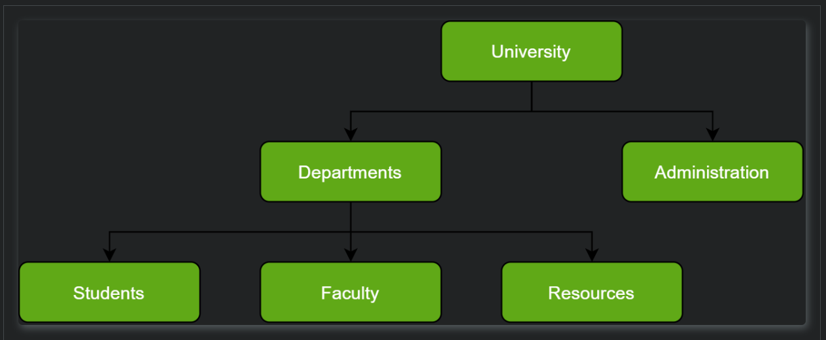
   3. Components of a hierarchical database
      1. Attributes
      2. Records
      3. Links
   4. A hierarchical database consists of a collection of records connected to each other through links. Each record is a collection of fields or attributes, each of which contains only one data value. A chiold record can only be linked to only one parent record
2. Network
   1. A network database is a hierarchical database but with one major tweak. The child records are given the freedom to associate with multiple parent records. As a result, a network or net of database files linked with multiple threads is observerd. Here is an example
   2. 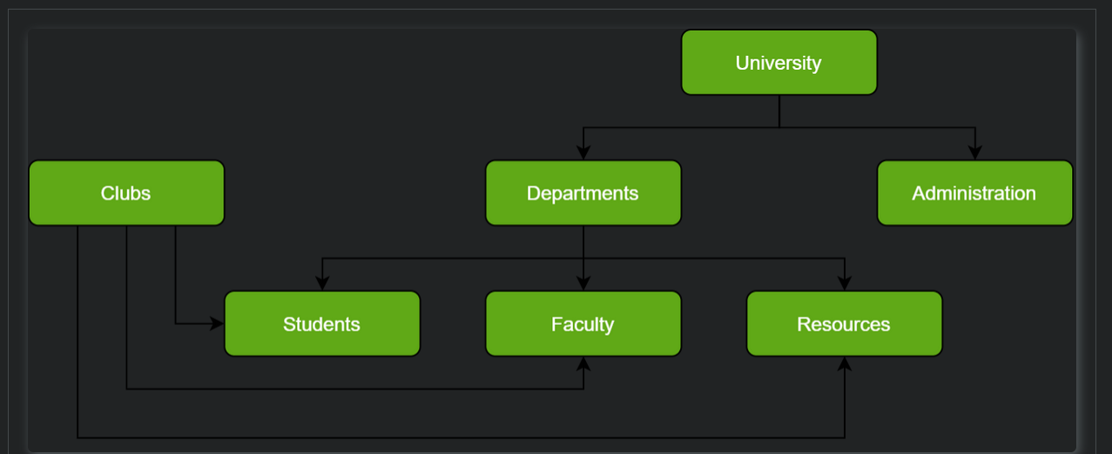
   3. Compinents of a network database
      1. Attribnutes
      2. Records
      3. Links
   4. A network database is consists of a collections of records connected to each other through links. Each record is a collection of fields or attributes, each of which contains only one data value. A child record can be linked to multiple parent records.
3. Relational
   1. Relational databases are the most mature of all databases and in theis database every record can be linked to everyother piece of record
   2. Components of a relational database
      1. Attributes
      2. Entity
      3. Relationships
      4. Cardinality
   3. A relationcal database is made up oif four components listed above. You will dive deeper into relational databases in the activities to come
4. NoSQL
   1. A NoSQL, originally refered to as a non-SQL database, is a non-relational database that providesa mechanism for the storage and retrieval of data. A NoSQL database includes simplicity of design, simpler horizontal scaling to clusters of machines, and finer control over availability. The data stuctures used by nosql databases are very different from tables in realational databases which make some operations faster in nosql

Database management systems

A database management system (DBMS) is essentially nothing more than a computerized data-keeping system. Users of the system are given facilities to perform sveral kinds of operations on such a system for either manipulation of the data in the database or the management of the database structure itself. DBMSs are categorized according to their database structures or types: hierarchical,network, and relational. You will see reference to RDBMSs which specifically refers to relational DBMSs